00d- Sprint Information and Retrospective

Part One: Task Management Board
Team number: Group 12 |  | Sprint number: Sprint 3
Link to Scrum Board: https://trello.com/invite/b/69f1252414c3094e343d62fe/ATTI08c02146cbf06f985e835fed3d7d8b55340072F9/-

Sprint Goal: Practice the final presentation and do some regression testing of our app.
Tasks Planned: 8 | Tasks Completed: 8 |  |  |  | Tasks Carried Over: 0
"Sprint Done" column:
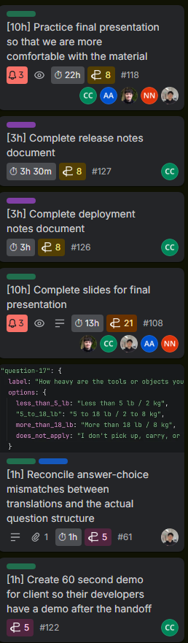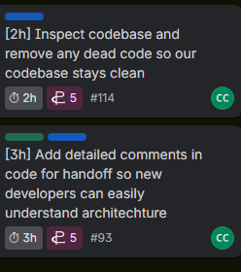

Part Two: Estimates and Actuals

Team Member | Estimated Work | Actual Work on Sprint | Variance (+/-) | Root Causes +  One-Sentence Explanation
Cole | 16h | 14h | -2h | - I spent most of the time practicing the final presentation, which I felt comfortable with after about 10 hours.
Nicholas | 16h | 15h | -1h | - I spent most of the time practicing the demo part of the presentation and helping team members with feedback for their portions.
Jonah | 16h | 13h | -3h | - I spent much of the time practicing the demo, in addition to a small bug fix. However, we had budgeted more time for bug fixes than needed.
Abdullah | 16h | 11h | -5h | - I spend time practicing for the presentation. We don't have that much work for this week, we kept this week for the presentation
Kyle | 16h | 16h | 0h | - I spent most of the time designing my slides and practicing my part of the presentation, which all went as planned.
Total | 80h | 69h | -11h | - While we budgeted lots of time for the presentation it still took less time than we thought.

Part Three: Retrospective

Individual:

1. What Went Well, appreciations, positive notes, etc
Name | Answer
Cole | The presentation was very good and we hit the time perfectly, all Q&A was answered well.
Jonah | Our presentation went well, and our client was happy with the product.
Abdullah | We presented well, covered all we wanted within the time frame we had.
Nicholas | I thought that we came up with a really good product at the end of the project and I was happy with the collaboration of the team.
Kyle | The presentation went well and the client is satisfied.

2. What Could Be Improved, noteworthy, needs change, etc
Name | Answer
Cole | We could have practiced the Q&A more to know who would take each question.
Jonah | We could have divided Q&A answers better, though most questions pertained to two of our sections, so it would have been difficult.
Abdullah | We could have paid more attention to the Q&A slide and made a clear plan.
Nicholas | I could have practiced the demo for the case where the API call fails.
Kyle | I could have answered more questions in Q&A.

3. Actions for Improvement, next steps, etc
Name | Answer
Cole | Hand off project files smoothly.
Jonah | Hand-off project files to client.
Abdullah | Create a Q&A plan
Nicholas | Give client project files.
Kyle | Submit all documents well.

Team:

5. Lessons Learned
- Practice pays off, we were able to shave 8 minutes off our first try.

6. Commitments for Next Time
- Practice as much as we did this time.

